**LIBRARY MANAGEMENT SYSTEM**

**(DESKTOP APPLICATION)**

**PROJECT REPORT**

**BY**

**SYED YASOOB RAZA**

**LIBRARY MANAGEMENT SYSTEM:**

This management have the following functionality:

* Sort and display books
* Add/Remove/Edit book
* Search catalogue
* Register new account/cancel membership
* Check-out book
* Reserve book
* Renew a book
* Return a book

**SORT AND DISPLAY BOOKS:**

For sorting I have used **quicksort algorithm**. This function sorts all the books according to the alphabetical order by title and display all the books

**Code:**

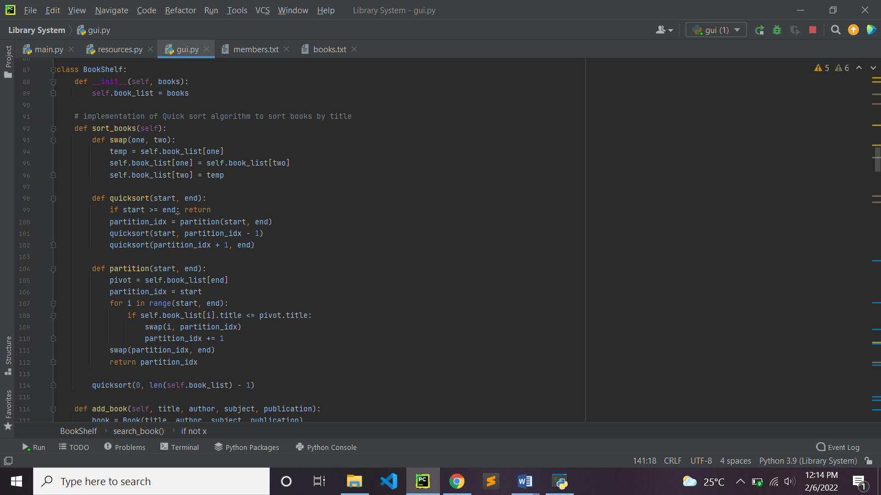

**Displaying all books:**

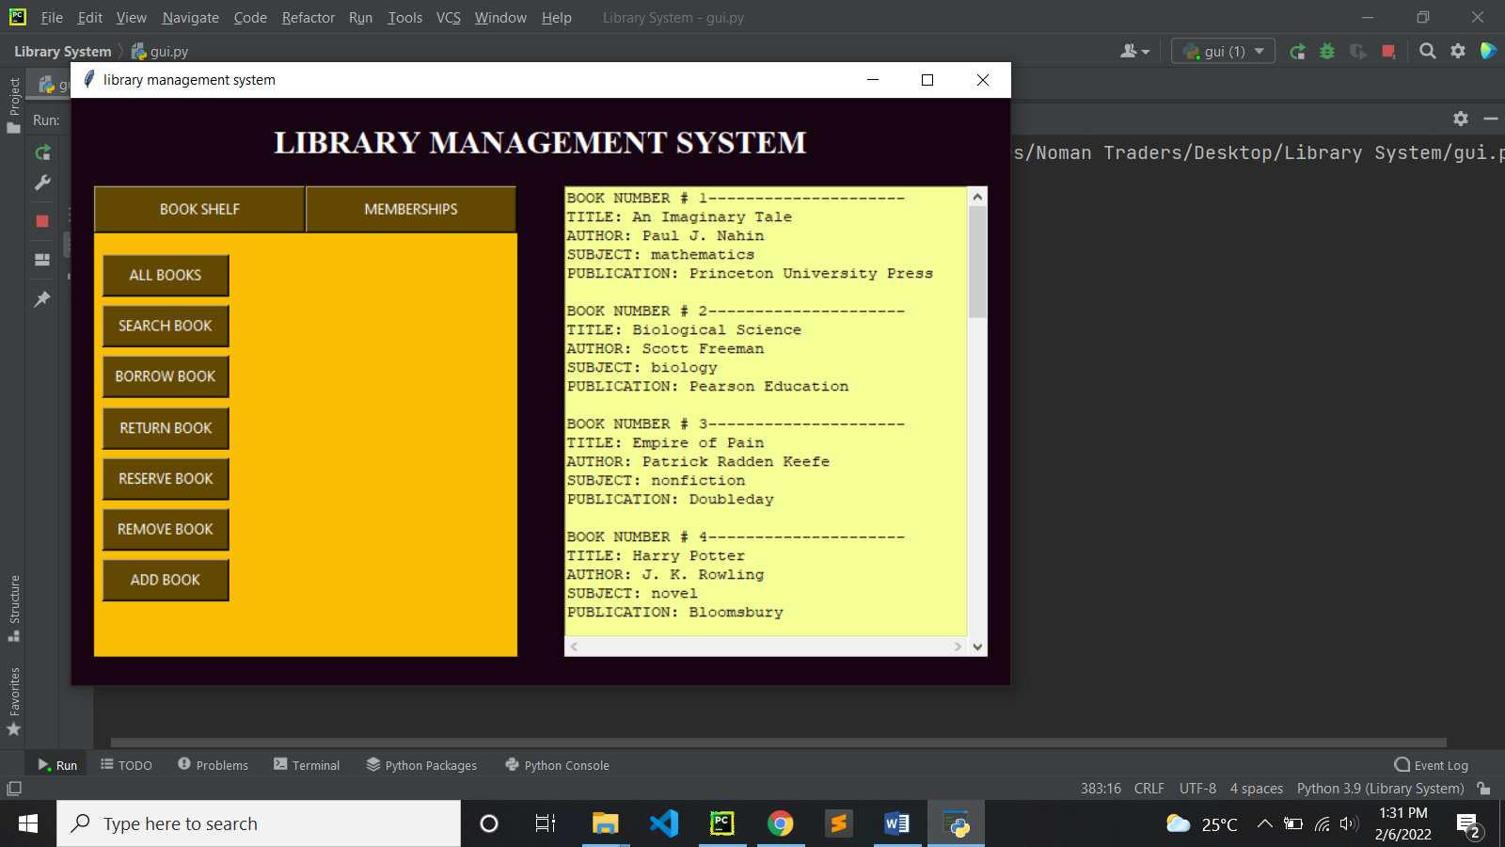

**ADD/REMOVE/EDIT BOOK:**

This functionality adds or remove a book from the library book shelf. to add a book, you need to give book title, author, subject, publication as input and the book will be added to the shelf.to remove a book you have to give book title as input, if the book is already in records it will remove it else give an appropriate message

**Code:**

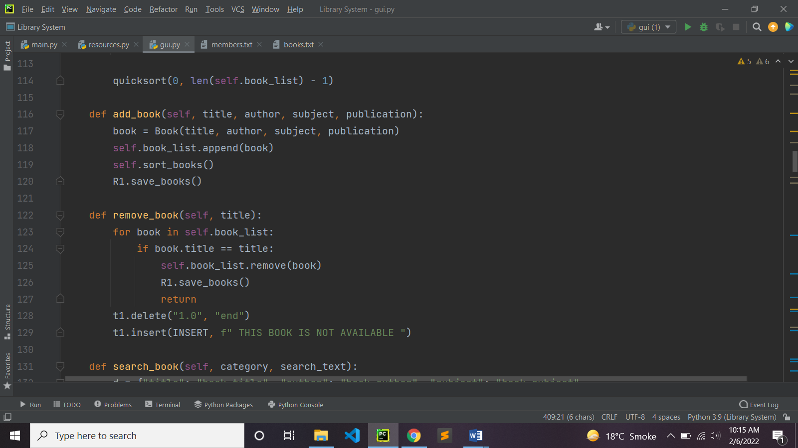

**Add book menu:**

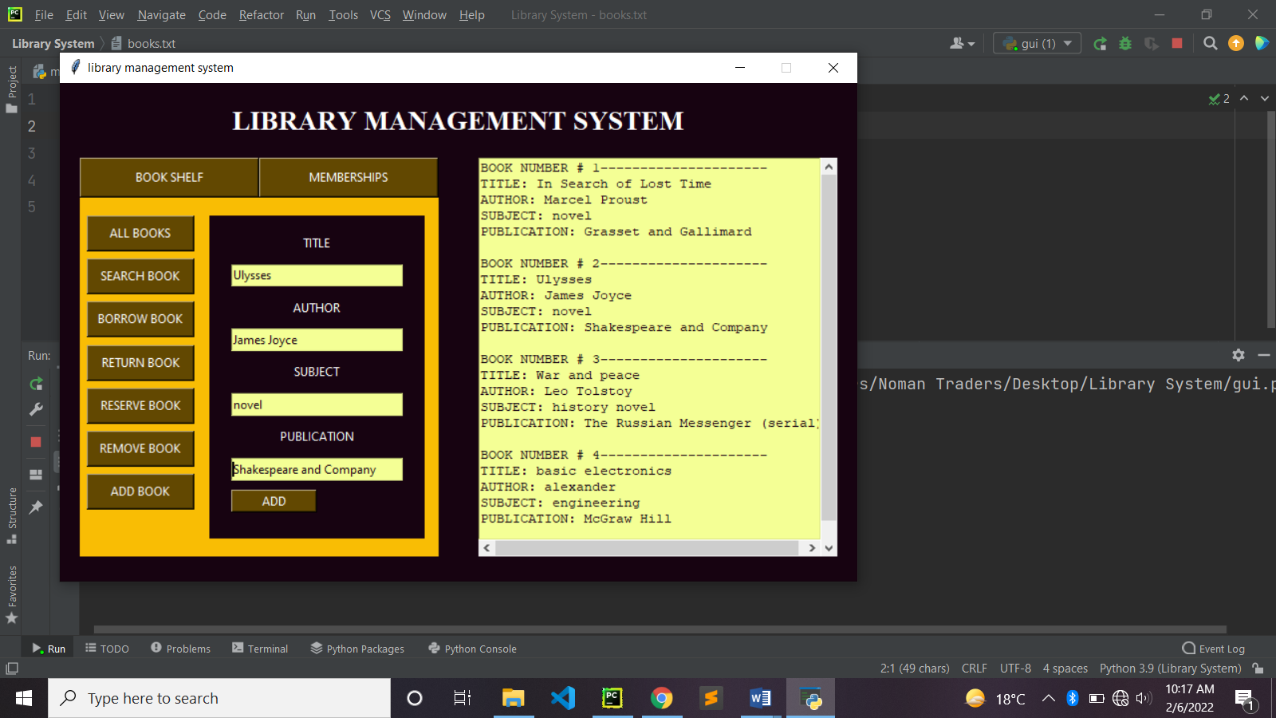

**Remove book menu:**

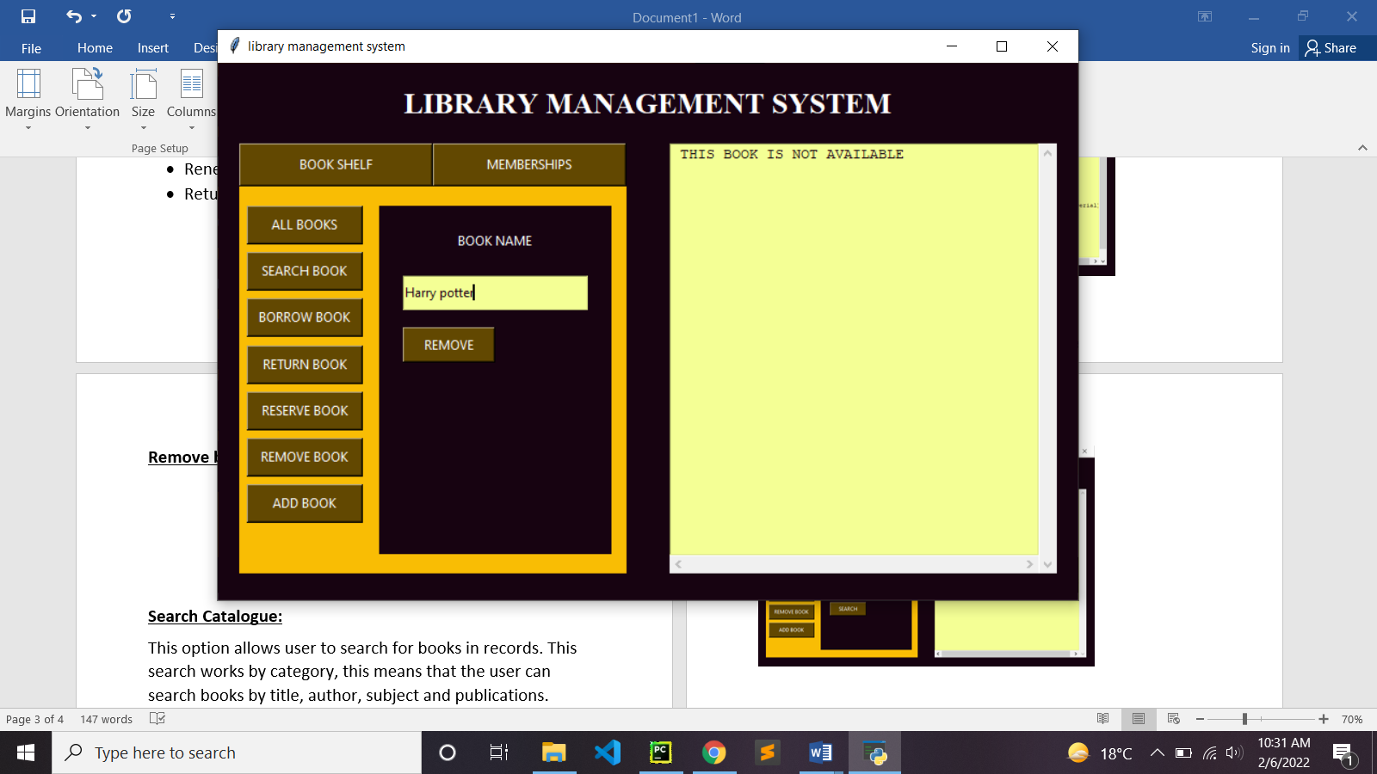

**SEARCH CATALOGUE:**

This option allows user to search for books in records. This search works by category, this means that the user can search books by title, author, subject and publications.

**Code:**

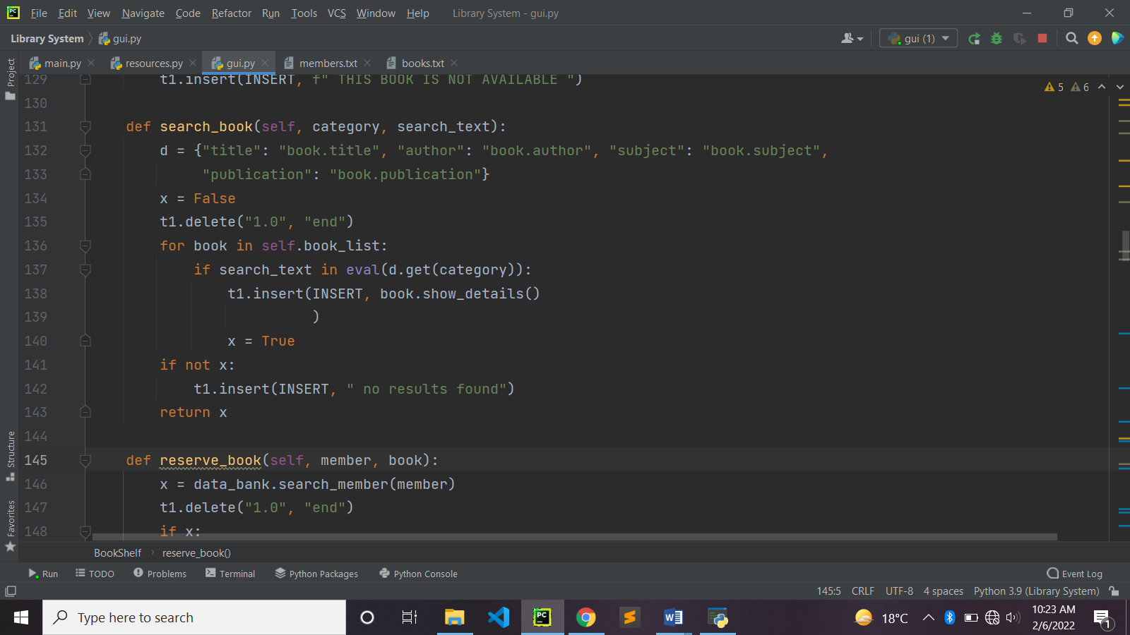

**Search menu:**

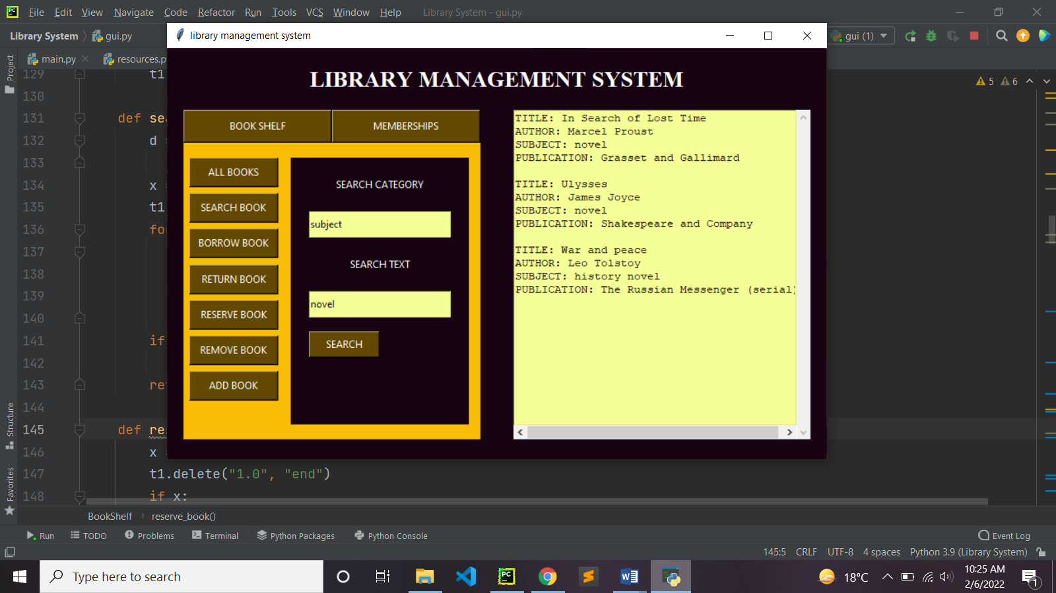

**REGISTER NEW ACCOUNT/CANCEL MEMBERSHIP:**

This option is used to register a new account or remove an existing account. To register a new member, it will require name, phone, email. To remove an account, it will take name and search in existing accounts if the account exist it will remove it else give an appropriate message

**Code:**

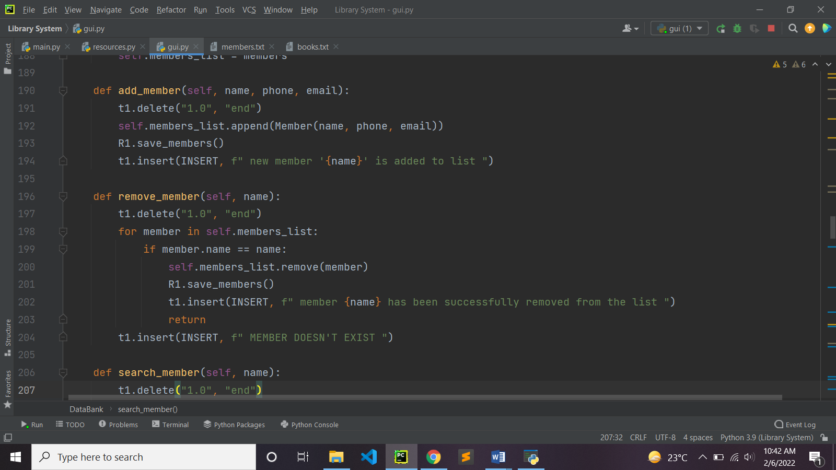

**Add account menu:**

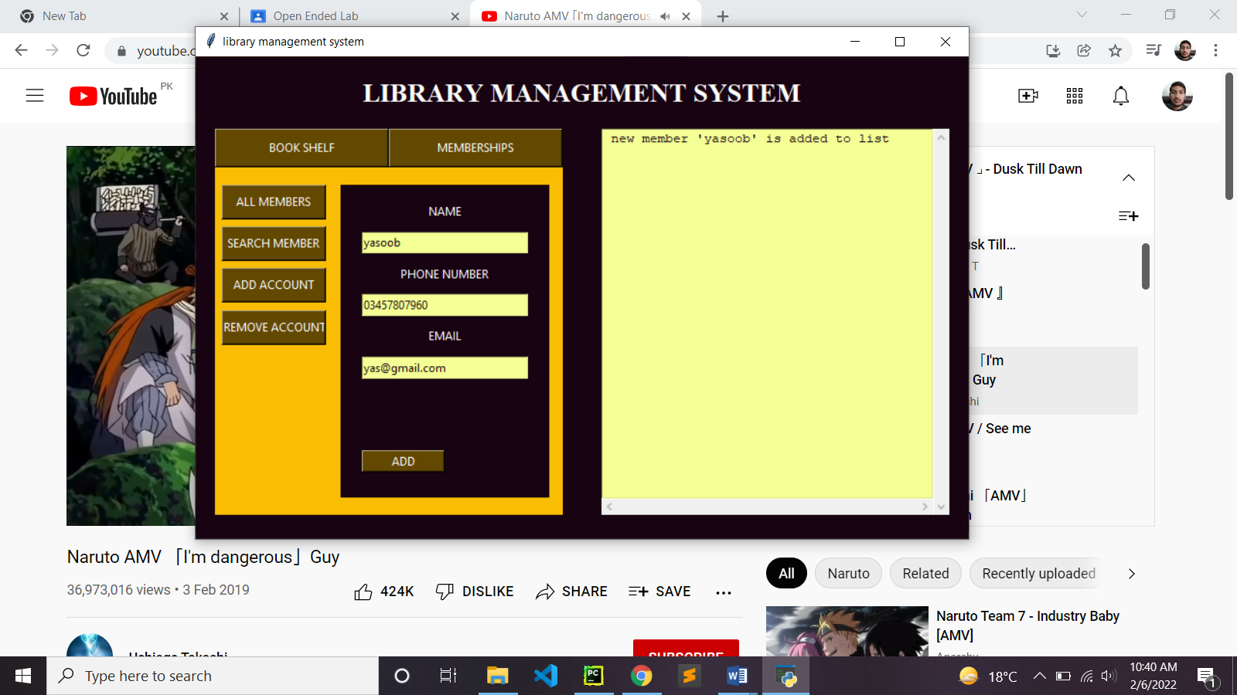

**Remove account:**

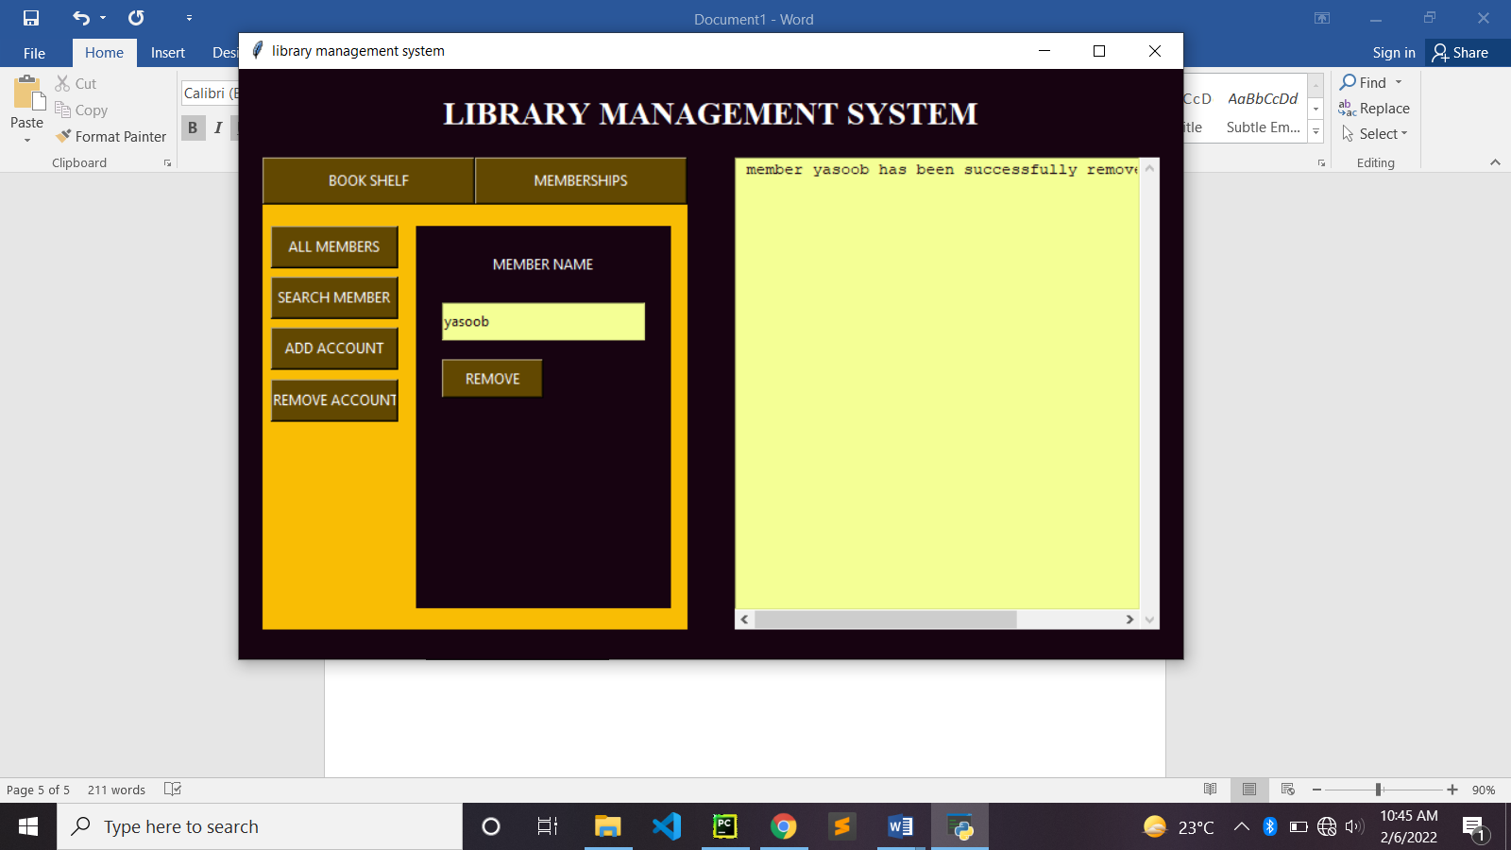

**CHECK-OUT BOOK / RENEW A BOOK:**

This option allows you to borrow a book. To borrow a book, it requires member name and book title. If the book is in shelf, then book will be borrowed and member’s records would be updated and book borrowed would be written in his records. Similarly, one can re borrow a book.

**Code:**

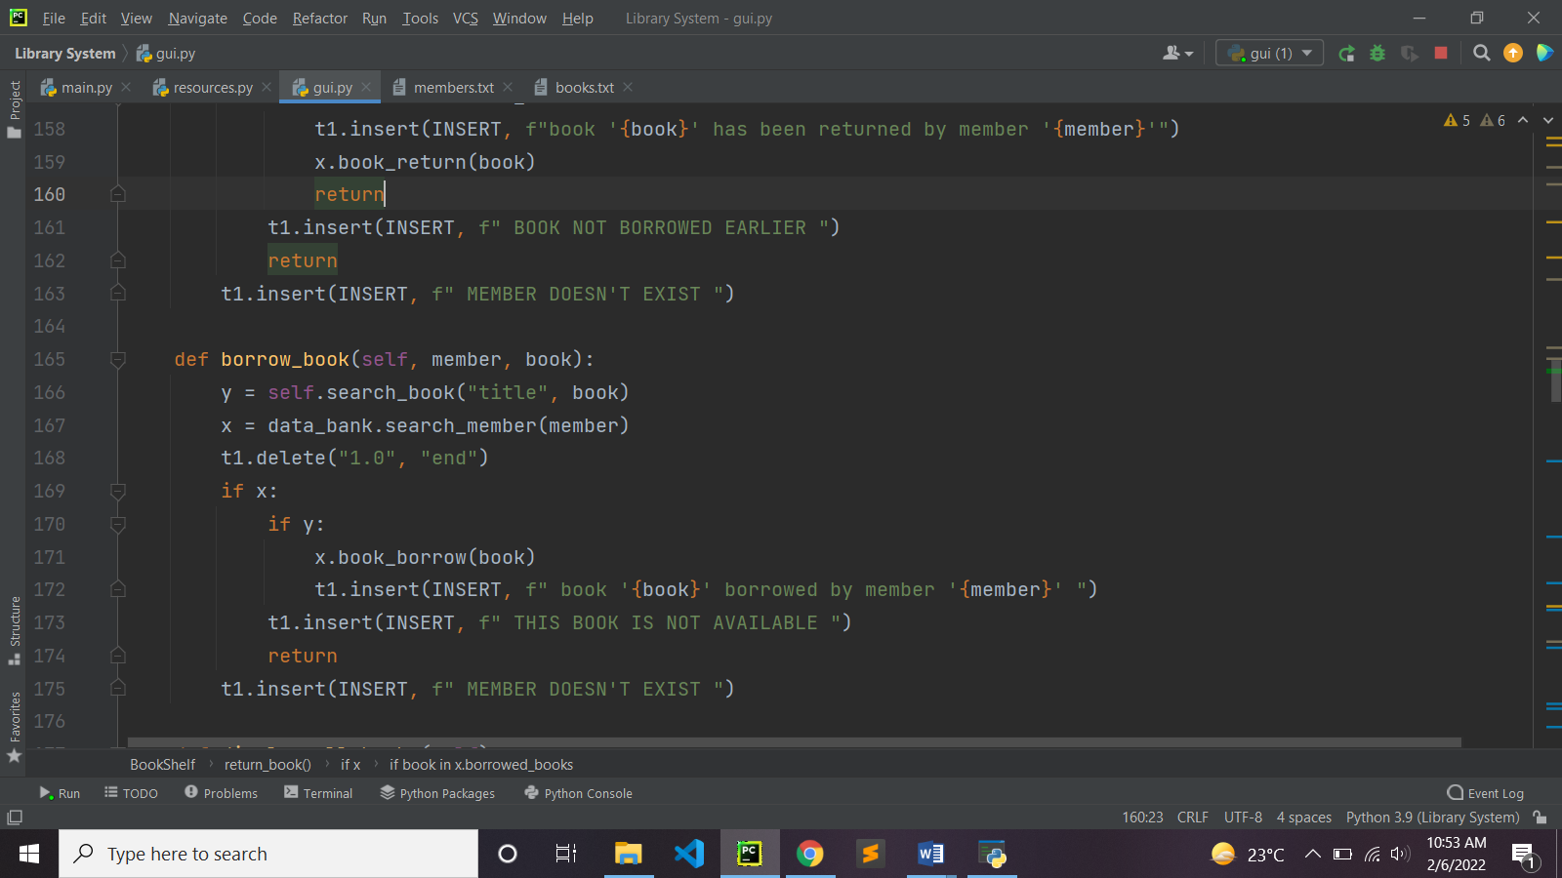

**Borrow book menu:**

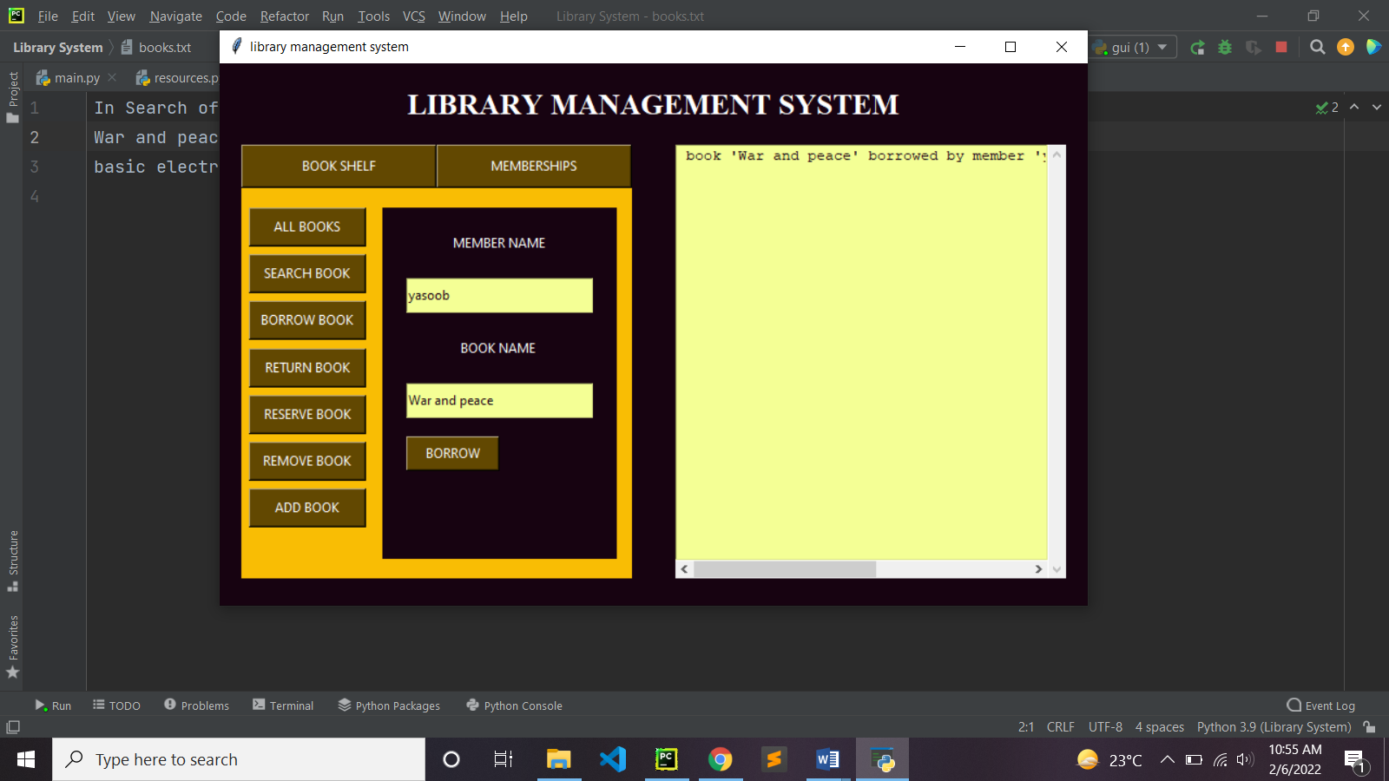

**RESERVE A BOOK:**

This option allows the user to reserve a book which is not available for now. It takes member name and book name as input to perform its operation.

**Code:**

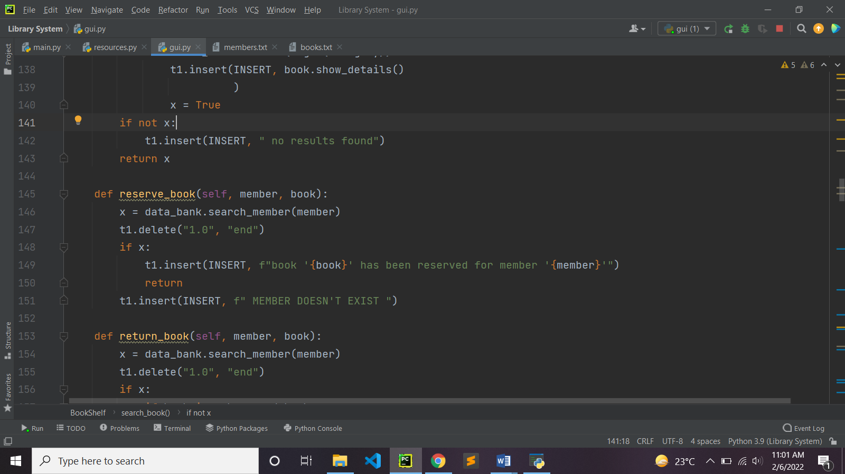

**Reserve book menu:**

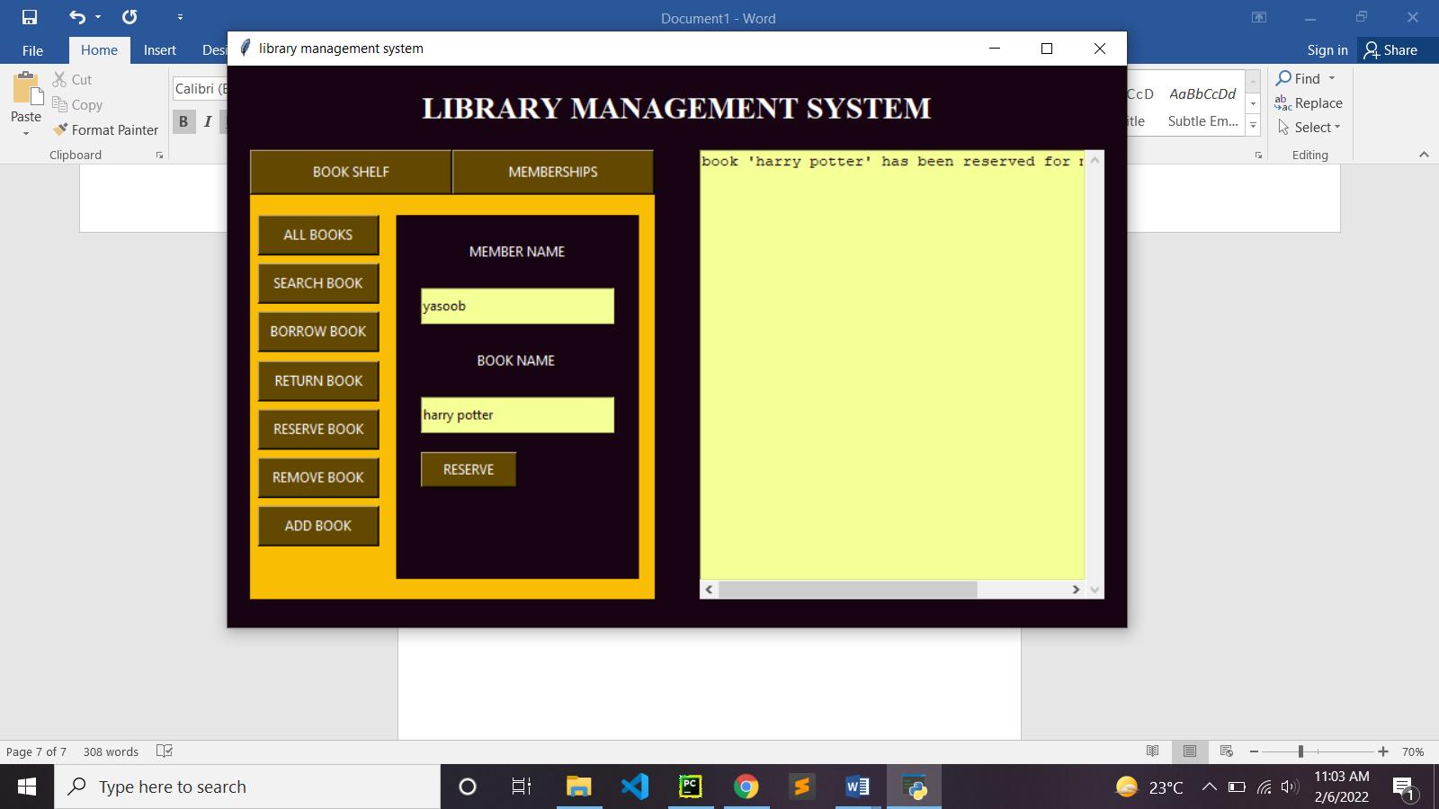

**RETURN A BOOK:**

This option is used to return a previously borrowed book, this takes member name and book title as input and remove the borrowed book from member’s record

**Code:**

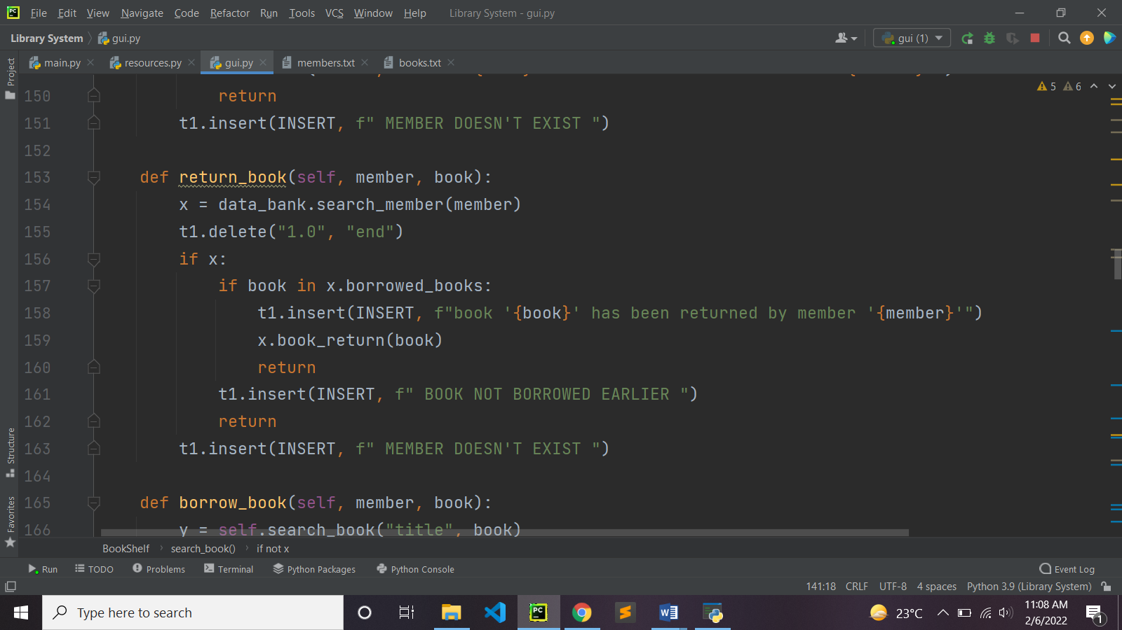

**Return book menu:**

